Chemistry PERIOD 4/5
Cameron Truong

Somatic Cloning

Bringing Extinct animals back
___
By Cameron Truong
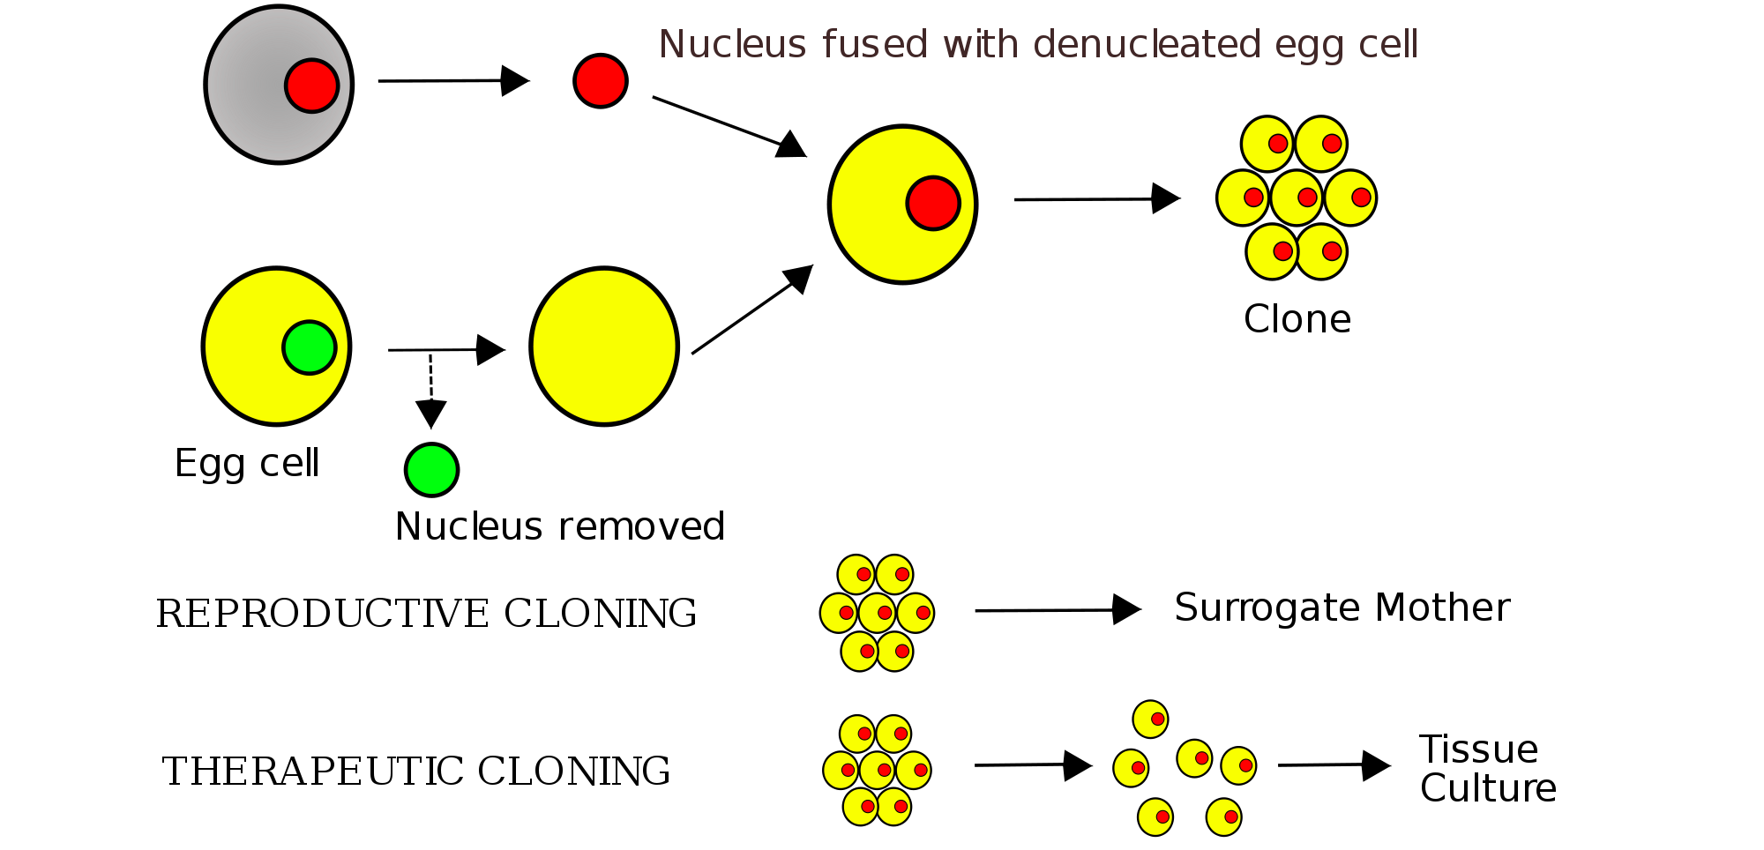

Somatic Cloning
Bringing back animals that have been gone since the stone age, seems like a far cry from achievable doesn't it? Think again, there is a process known as somatic cloning which is simplified in the diagram above. A somatic cell is any cell that isn't a sperm or egg cell that contains the genetic blueprint of the animal. When the nucleus is removed from a healthy egg cell it is fused with the nucleus of the somatic cell and it is then cultured and introduced to a surrogate mother. The scientist stimulates the fused egg and tricks it into thinking it is fertilized. It is then cultured until it becomes an embryo it is then put into the surrogate mother so it can be birthed. By doing this we can bring back animals that have gone extinct. But cloning doesn't just have to do with animals, we can also clone meat and humans. However, cloning humans is argued to be inhumane.But cloning animals has been a thing since 1885; Hans Adolf was the first man to successfully clone a living creature. He did this to prove that nucleating an egg cell and implementing dna from an animal can be cultured and eventually born as a clone.

Throughout our existence on earth we have destroyed wildlife in various ways. For instance, clearing land, burning down forests, etc. Because of this it has driven many animals out of their homes and in many cases caused species to eventually go extinct and throw off the food chain. Cloning animals can slowly help species come back from extinction and bring back ones that will help other species thrive. One of the major causes for species to go endangered or extinct is deforestation. Every year 46-58 thousand square miles of forests are removed. You can only imagine the damage that this would have on local wildlife. Many animals like the giant panda, the mountain gorilla, and the tiger all are endangered because of it. Although cloning can't solve the deforestation problem it can be a way to bring back animals that are affected by it. Also if Zoos are trying to reproduce and bring back a certain species they can use cloning to change the DNA to keep them from causing excessive inbreeding and creating deformed offspring. It also leads way to create interspecies and breed different types of species together to make genetically “pure” animals.

Even though these are great reasons there are some flaws to cloning. There is a fairly large failure rate. Dolly the sheep is a good example, it took 227 attempts to completely create a healthy version of the original sheep. The cloned babies that do survive tend to be bigger than their original counterpart and that could lead to blood and breathing problems. The success rate only runs from about .1 percent to 3 percent. Also to add onto the .1-3 percent success rate, the implantation of the embryo plus the birth, still have a pretty high chance of failing. Therefore making it a slow and not always worth while to help a certain species comeback from endangerment. Now this is still very worth it to try and bring back a recently extinct animal, I said recently because it is physically impossible to clone anything that has been dead for more than a few hundred thousand years. Some skeptics believe that scientists will go too far and bring back a T-rex or some other huge meat eating beast. This would not be the case because it is impossible to collect proper DNA from a fossil that has decayed for millions of years.
There are multiple complications that come with cloning, although scientists have worked very hard to make this a reality. There isn't a set solution to the problems related to cloning yet because it's entirely based on how much DNA they can retrieve and the trial and error associated with testing. There are so many issues with cloning at this point in time that it doesn't seem like a viable option to “bring back” extinct animals. There have been many cases where the offspring don't have enough strength in their body and end up dying within minutes of life. Something happens during the culturing process and the animal becomes deformed and are sometimes born bigger than regular offspring. As of right now, there aren't any viable solutions that could be used to ease the process of cloning. It's a long painstaking procedure that takes mass amounts of time and money. It could easily cost 50,000 for a single egg.
Other than bringing back animals that were recently extinct or deceased, cloning can be used in a number of different scenarios. It can help us better understand diseases, grow healthy organs for people that need them, reproduce meat that can be used as a substitute for slaughtering animals. Cows and other animals can have a drug implantation to produce meat or milk healthier for us, and when the next generation comes along and the next you would eventually have a herd of animals that produce healthier batches of produce. Our population is growing, by 2050 there will be 10 billion of us and not enough livestock to keep us going. There is a TED talk about how there is going to be a need for 100 billion land animals to provide for us. He proposes this idea to clone meat so we don't rely on our delicious friends. In this situation it would benefit almost everyone. It will help the whole population of earth (besides vegans and vegetarians) by letting us create factories that could produce mass amounts of food instead of completely obliterating the livestock population.
After much research behind this topic I still stand firm with my original opinion. Cloning animals could have so much affect on our lives by letting us experience animals that have been off this earth for thousands of years, help us produce medicine, and help feed our ever growing population. This discovery is needed in this world because it allows scientists to do more testing to help cure diseases that happen pre birth to animals and humans, our growing population is also a huge problem and we need to take charge and get more people on board with cloning, by educating people and young about the long term benefits of cloning. Having more talks about how we will need cloning in the future will help the majority understand what exactly it could do for us and the earth.

